POLYMER CHEMISTRY
Polymers
- A polymers are macromolecule with high molecular mass compound ranging from 5000 to one million
- Polymers can be defined as the large molecules (macro molecular) formed by the linkage of small molecules called monomers. (In Greek poly means many & mero means units)
- The process by which polymers are obtained is called polymerization
- For e.g. polyethylene is obtained by repeating ethylene unit as a result of polymerization.
- It is also interesting to note that many carbohydrates, Proteins & enzymes, DNA & RNA are natural polymers.

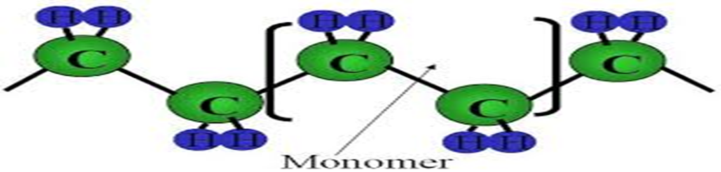

Polymers form very important components in our daily life. The polymers are highly useful in domestic industrial & medical fields. The following are the reasons for the extensive use of polymers over conventional materials like metals, woods and ceramics
- Most of the polymers are non-toxic & safe to use

- They have low densities (light in weight) so transportation polymers will be easy.

- They posses good mechanical strength.

- These are resistant to corrosion and will not absorb moisture when exposed to the atmosphere.

- They are bad conductor of heat and electrical insulators.

- These can be molded and fabricate easily and at faster rate.

- They can be imparted with desired color.

- Polymers material are easily moldable into complex shape with reproducible dimensions
- Polymers materials are tailor made i.e. depending upon need they can be made transparent, opaque, hard, flexible, fiber, plastic or elastomers.

- They can be manufactured at relatively lower cost and in faster rate.
But the limitations for the use of polymers are

  - Some polymers are combustible.

  - The properties of polymers are time dependent

  - Some of them cannot with stand high temperature.

CLASSIFICATION OF POLYMERS

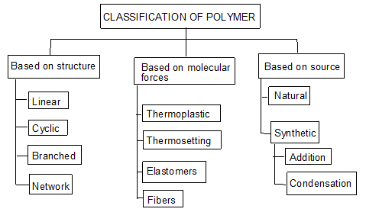

Classification based on source
- Naturally occurring Polymers: These occur in plants and animals and are very essential for life e.g. starch, cellulose, amino acids, etc.
- Synthetic polymers: These polymers are prepared in laboratory they are man made polymers e.g. plastics, synthetic rubbers, etc.
- Semi synthetic polymers: These are derived from naturally occurring polymers by chemical modification. e.g. vulcanized rubber, Cuprammonium silk and Cuprammonium rayon, etc.

Based on magnitude of intermolecular forces
- Elastomers: In these polymers, chains are held by weakest intermolecular forces which permit the polymers to be stretched. The polymer regains its original position when forces are released.
- Fibers: In these polymers the inter molecular forces are strong due to hydrogen bonding, cross linking , cyclic structure
- Thermoplastics: These are polymers for which inter molecular forces between elastomers and fibers. Due to this they can be easily molded by heating.
- Thermosetting polymers: Thermosetting polymers undergo chemical changes and cross linking on heating and become permanently hard and infusible.

Tacticity:-
The arrangement of functional groups on carbon backbone of the polymer is called Tacticiy.
It is manly divided into 3 types.

- Isotactic polymers: Those polymers in which the functional groups are arranged on the

same side are called Isotactic polymers. E.g.
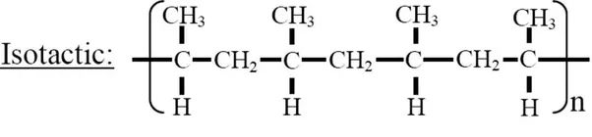

- Atactic polymers: When there is no regular arrangement of functional groups on the back bone of the polymer chain these polymers are called atactic polymers.

E.g.:
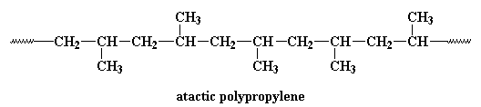

- Syndiotactic Polymers: The polymers with alternate arrangement of functional groups
are called syndiotactic polymers for e.g.:-

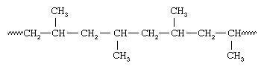

Mechanism of polymerization (Types of polymerization)
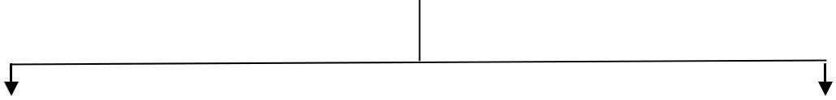

Chain polymerization

Step polymerization

(or)
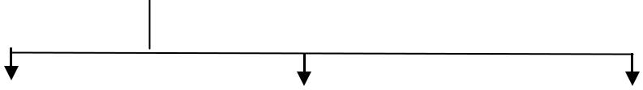
Additional polymerization
(or)
Condensation polymerization

Free radical

Ionic chain

Co-ordination chain

Ionic Polymerization
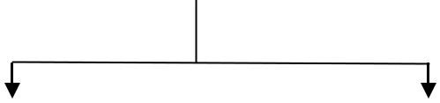

Cationic chain Anionic chain

Types of Polymerisation:-

There are two types of polymerization. They are

- Addition Polymerization
- Condensation Polymerization

- Addition polymerization :- Polymer synthesized by addition polymerization have same empirical formula as that of monomer. No molecule is evolved during polymerization. Molecular mass of polymer is exact multiple of monomers.
When the same kind of monomers joins, the polymer is called homopolymer.
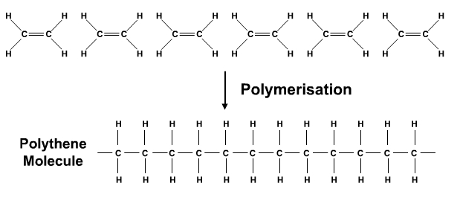
- Condensation Polymerization:
Condensation polymers are those in which two like or unlike monomers join each other by the elimination of small molecules such as H₂O, HCl, etc. It takes place by condensation of two different bi, tri, poly functional group monomers having affinity for each other. It always accompanies with elimination of small molecules like H₂O, HCl etc.
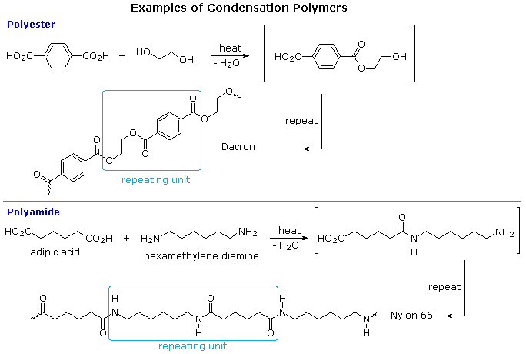
Difference between condensation of addition polymerisation:-

 | Condensation polymerization |  | Addition polymerisation
(1) | It is also known as step growth | (1) | It is also known as chain growth
 | Polymerization |  | polymerization
(2) | It takes place in monomers having | (2) | It takes place only in monomers
 | reactive functional groups |  | having multiple bonds.
(3) | It takes place with elimination of | (3) | It takes place without elimination of
 | simple molecule like H₂O,NH₃,HCl |  | simple molecule.
 | etc.,
(4) | Repeat units of monomers are | (4) | Repeat units & monomers are same.
 | Different
(5) | The polymer is formed in gradual | (5) | Reaction is fast and polymer is formed
 | Steps |  | at once.
(6) | The molecular mass of polymer | (6) | There is very little change in the
 | increases throughout the reaction |  | molecular mass throughout the
 |  |  | reaction
(7) | Product obtained may be | (7) | Product obtained are thermoplastic
 | thermosetting/thermoplastic
(8) | E.g.:- Bakelite, polyester ,polyamides | (8) | E.g:-Polyethylene, PVC, poly styrene.
 | etc.,

Molecular Mass of Polymer

- The molecular mass of polymer is an important property of polymer because many important properties of properties are influenced by molecular mass. Polymers with higher molecular mass are tougher and more resistant. Their viscosities and softening temperature are also higher. Thus polymers with molecular mass are often required for particular purposes.
- Molecular mass of polymer is not a fixed or constant value like organic compound. Their molecular mass is controlled by polymerization reaction, which in turn depend upon availability of functional group, charge carrier, life time of charge carriers. Because of random nature of growth process, the product of polymerization process is mixture of chains of different length.
- Hence polymers are poly disperse mixture of various molecular mass polymers. Therefore molecular mass of polymers is average molecular mass

Average molecular mass of polymers can be expressed in following ways

- Nummber Average Molecular Mass (Mn)
- Weight Average Molecular Mass (Mw)
- Z-Average Molecular Mass (Mz)
- Viscosity average Molecular Mass (Mv)
Number average Molecular Mass ( Mn)

The colligative properties of polymer solution determined, which counts number of molecules in a given volume of mass. Each molecule makes equal contribution to the colligative properties regardless of molecular mass or size. Hence molecular mass obtained by colligative properties measurement is known as number average molecular mass Mn.

Let n₁, n₂, n₃, …… be the no of polymer molecules with molecular mass m₁, m₂, m₃, …… respectively. Then number average molecular mass is given by

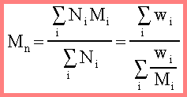

Weight average Molecular Mass (Mw)
When the molecular mass is average according to mass of molecules, weight average molecular mass is obtained. It is determined by light scattering measurement and sedimentation methods

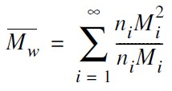

Z-average Molecular Mass (M_{Z}):
Mz is proportional to the mean cubic molecular mass and is determined by measuring the radial distribution of refractive index gradient in sedimentation equilibrium.
It is defined by the formula
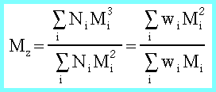

Viscosity average Molecular Mass (Mv):

Mv is obtained by viscosity measurements.It is defined by the formula

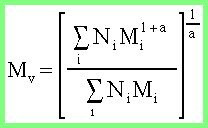

Methods to determine Molecular Mass of Polymer:
I. Determination of weight average molecular Mass:

Viscosity is an internal property of a fluid that offers resistance to flow. It is due to the internal friction of molecules and mainly depends on the nature & temperature of the liquid. Many methods are available for measuring viscosity of polymer solution. The Ostwald method is a simple method for the measurement of viscosity, in which viscosity of liquid is measured by comparing the viscosity of an unknown liquid with that of liquid whose viscosity is known. In this method viscosity of liquid is measured by comparing the flow times of two liquids of equal volumes using same viscometer.

The molecular weight of the polymer is measured by using viscometer and the molecular weight obtained by this technique is called viscosity average molecular weight. The molecular weight of the polymer solution is very high so the viscosity of polymer solution is very high compared to that of pure solvent.

From the Mark-Houwink equation the relationship among the molecular weight and viscosity are given below

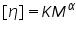

Where ή is the intrinsic viscosity , M is Molecular weight, K and alpha are constants for a particular polymer solvent system.
If we know the K and alpha values for a given polymer solution the intrinsic viscosity and molecular weight can be calculate using the above equation.

Types of Plastic: - (1) Thermoplastics

(2)Thermosetting plastics.

Difference between thermoplastic & thermosetting resins:-

Thermoplastic resins (or) Polymers |  | Thermosetting resins
(1) | These are produced by additional polymerization | (1) | These are produced by condensation polymerization.
(2) | The resins are made of long chains attached by weak Vander Waal’s force of attraction | (2) | The resins have three dimensional network structure connected bonds.
(3) | On heating they soften and on cooling become stiff chemical nature won’t change | (3) | On heating they become stiff & hard. No change on cooling. Chemical nature changes.
(4) | They can be remoulded because once set means they are permanently set | (4) | They cannot be remoulded because once set means they are permanently set
(5) | They can be recycled | (5) | They can not be recycled.
(6) | The resins are soft, weak and less brittle | (6) | The resins are soft, weak and less brittle
(7) | These are easily soluble in some organic substances | (7) | These are not soluble in some organic substances
(8) | Contain long chain polymer with no cross linkage | (8) | They have 3D network structure.
(9) | .E.g. Polyehylne | (9) | e.g. Bakelite

Compounding of plastics:-

Compounding of plastics:- Compounding of plastics may be defined as the mixing of different materials like plasticizers, fillers of extenders, lubricants, pigments to the thermoplastic & thermosetting resins to increase their useful properties like strength, toughness, etc.
Resins have plasticity or binding property, but need other ingredients to be mixed with them for fabrication into useful shapes.

Ingredients used in compounding o plastics are

- Resins:- The product of polymerization is called resins and this forms the major portion of the body of plastics. It is the binder, which holds the different constituents together. Thermosetting resins are usually, supplied as linear – polymers of comparatively low molecular weight, because at this stage they are fusible and hence, mouldable. The conversion of this fusible form into cross-linked infusible form takes place, during moulding itself, in presence of catalysts etc. They also decide the type of treatment during moulding operation

- Fillers (or) extenders:- Fillers are generally added to thermosetting plastics to increase elasticity and crack resistance. These additives acts as a extenders and reduce cost of final produts. Fillers reduce cost of the plastic without affecting its original properties. Highest % can be up to 50 %, which depends upon type of plastic The fillers which increase mechanical strength are known as reinforce fillers
Eg.
Organic fillers: wood powder, cotton pulp, carbon black, graphite, powdered rubber
Inorganic fillers: Asbestos, powdered mica, clays, chalc, talc, Zn & Pb oxides, Cd & Ba sulphides, carborundum.

- Dyes and pigments:- Dyes or pigments are generally used to impart desired coloured to molded plastics. Dyes are used in transparent plastics and pigments are used in all polymers. It is desired that they should have high covering power and ability to processing Organic dyes and inorganic pigments

Eg. Azo dyes, chromate pigments, TiO₂, Carbon Black, Lead chromate (yellow), ferro cyanide (blue)

- Plasticizers: This increase the flexibility and mouldability and to decrease brittleness of the materials. It also lowers the temperature of moulding operation.Increase workability and flame proofness of plastics.Only used in thermo-softening plastics.When they mixed with the resin, they get uniformly distributed between the molecules and reduce intermolecular attraction between original polymer molecules.Thus the plastic becomes flexible.They can be added upto 10 %. Generally liquid plasticizers are used, hence the only disadvantage is, if they are not consistent they could ooze out from the finished product.
- e.g. Cresyl diphenyl phosphate
- Tricresyl phosphate
- Triphenyl phosphate
- Esters of oleic and stearic acids

- Catalyst or Accelerators: They are used for thermosets to increase the rate of cross-linking. Acidic or basic catalysts can be used. They are required in small quantities
Eg. Benzoyl peroxide, hydrogen peroxide, metal oxides

- Stabilizers:- Stabilizers are used to improve the thermal stability of plastics, e.g.:- PVC. At moulding temperature, PVC undergoes decomposition & decolourisation. So during their moulding, stabilizers are used. E.g.:- white lead, lead chromate, Diethyl phthalate, Adipic acid esters

- Lubricants: Especially help during low or room temperature moulding This gives the glossy finish to the final product. As lubricants get dispersed on the surface and occupies a layer between article and mould This prevents sticking of an article to the mould and its easier separation from the mould
Eg. Soaps, waxes

FABRICATION OF PLASTICS

Giving any desired shape to the plastics (granules or powders) by using mould under the application of heat and pressure.
A proper method is to be selected depending on the shape and type of resin used.
Methods involve partial melting of resinous mass by heating.
In case of thermo-pasts molten resin is introduced in die/mould and desired shape could be achieved by compression and further cooling.
In case of thermo-sets partially polymerized mass or raw materials are introduced in the die/mould, which further cured at high temperature in the mould itself to achieve desired shape.
- In case of thermoplasts, curing is done at room temperature (low temperature)
- In case of thermosets, curing is done at high temperature to obtain desired
cross-linking

TYPES OF FABRICATION
- Compression Molding (Suitable for Thermosets / Thermoplasts)
- Injection Molding (Suitable for Thermoplasts)
- Transfer Molding (Suitable for Thermosets)
- Extrusion Molding (Suitable for Thermoplasts)

I COMPRESSION MOLDING
- Common and oldest method for molding thermosetting / thermoplastic materials
- Compression of raw materials or soften resinous mass is done in the mould/die under heat and pressure
- Predetermined quantity of raw materials is introduced carefully in the mould, further compressed by hydraulic pressure (2000 to 10000 psi)
- Molten or soften resinous mass gets filled in the cavity of mould.
- Curing is done by heating (Thermosetting) or by cooling (Thermoplastics)
- Finally moulded article is separated from the mould by opening the mould apart.
- Applications : Electric switch boxes, Ash trays, cabinets for radio, television, computers etc.

Disadvantage:
Greater waste Compression moulding is not such a precise method of making a product as injection moulding because the mould cavity has to be overfilled to some degree to achieve the correct pressure to cure the part. whereas an injection mould is more precisely filled Waste thermoset cannot be melted down and reused so the cost of the part must reflect this.
Higher labour cost This production technique is essentially simple, but it does require more man power

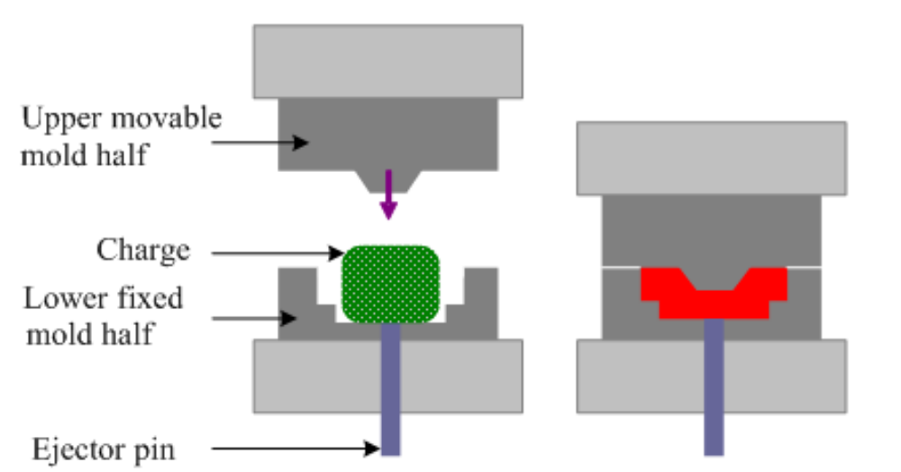

II. INJECTION MOLDING

- This method is especially used for thermoplastic materials
- Powder or granular resin is heated in a cylinder and injected at a controlled rate in a mould with the help of piston plunger or screw.
- Piston plunger or screw is used to force the material in mould.
- Pressure upto 2000 kg/cm² (100 psi) is used
- Once the article is formed mould is cooled and half mould is opened to remove the finished article.
- Disadvantage of the method is formation of air bubbles or cavities in the articles
- Applications: Smaller but large volume articles such as, pen caps, bottle caps, cups, containers, mechanical parts
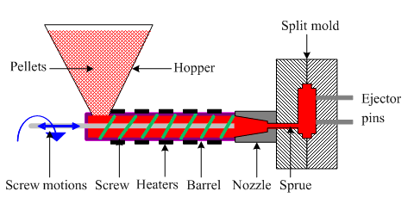

III. TRANSFER MOLDING
- The method combines features of both Compression Molding (hydraulic pressing of molding materials - thermosets) and Injection Molding (ram-plunger and filling the mold through a sprue).
- The method is used especially for molding thermosetting resins (thermosets)
- Products with relatively intricate designs could be fabricated with this method
- Powdered raw materials are heated at certain low temperature to soften and then introduced through an orifice or sprue in the mould
- Then it is cured in the mould at high temperature for certain time
- Finally the moulded article is removed by separation of mould
Advantages:
Articles with intricate shapes could be designed
Aerospace and automobile parts, car body, helmets
The articles produced are blister free
Fine wires and glass fibers can be inserted in the mould
Even thick pieces can be cured completely and uniformly

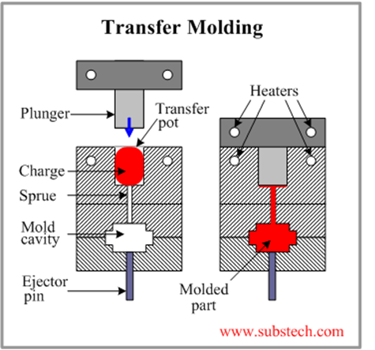

IV. Extrusion Molding

Whenever continuous molding of material like wires, cables, and sheets is required extrusion molding is used. The thermoplastic materials are molded by this method. They undergo continuous molding to form articles of uniform cross section. In this method, the thermoplastic material are heated to plastic condition and pushed by means of screw conveyor in to a mould cavity having required outer shape of articles to be manufactured. Here the plastic mass gets cooled due to atmosphereic exposure. A long conveyor carrie

s away the cooled products continusly.

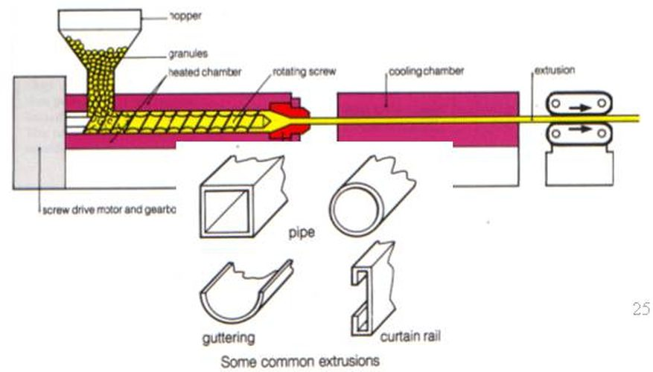

Vertical Extrusion Molding
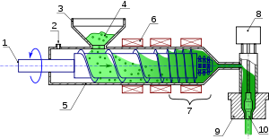

Preparation, Properties and uses of IMPORTANT POLYMERS:

POLY VINYL ACETATE (PVAc):

Polyvinyl acetate is a substance produced through the combining of many units of monomeric vinyl acetate (CH3COOCH=CH2). The number of units so combined is typically between 100 and 5,000. This translates to an average molecular weight of between 850 and 40,000. Polyvinyl acetate may be used as is or modified through chemical reactions to produce other important polymeric substances

Preparation:
Monomeric vinyl acetate was once prepared by reacting acetylene with anhydrous acetic acid in the presence of a mercurous sulfate catalyst; poly vinyl acetate is prepared by free radical vinyl polymerization as follows

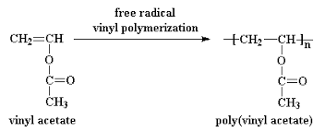

Properties:
Polyvinyl acetate is an amorphous polymer. The hardest of the polyvinyl esters, polyvinyl acetate offers good adhesion to most surfaces. Unlike some other thermoplastics, it will not turn yellow. Polyvinyl acetate does not cross-link, thus becoming insoluble, and it can be dissolved in many solvents other than water.

Uses:

Emulsified polyvinyl acetate is used in water-based adhesives, including pastes and glues. One of the uses for emulsified polyvinyl acetate is in bookbinding. Polyvinyl acetate offers acceptable gap-filling capability. It may be used as a resinous component of latex paints, offering compatibility with a wide-range of other paint chemicals. Polyvinyl acetate may be used in the lamination of metal foils. Non-emulsified, or waterless, polyvinyl acetate is useful as a thermosetting adhesive.

POLYMETHYL METHCRYLATE (PMMA) PLEXI GLASS

Poly(methyl methacrylate) (PMMA), also known as acrylic or acrylic glass as well as by the trade names Crylux, Plexiglas, Acrylite, Lucite is a transparent thermoplastic

PREPARATION:
PMMA is routinely produced by emulsion polymerization, solution polymerization, and bulk polymerization. Generally, radical initiation is used

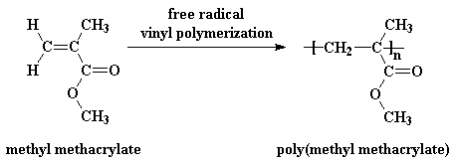

Properties:
PMMA is a strong, tough, and lightweight material. It has a density of 1.17–1.20 g/cm³, which is less than half that of glass.
It also has good impact strength, higher than both glass and polystyrene; however, PMMA's impact strength is still significantly lower than polycarbonate
PMMA transmits up to 92% of visible light (3 mm thickness), and gives a reflection of about 4% from each of its surfaces due to its refractive index (1.4905 at 589.3 nm).
It filters ultraviolet (UV) light at wavelengths below about 300 nm
PMMA swells and dissolves in many organic solvents; it also has poor resistance to many other chemicals due to its easily hydrolyzed ester

Uses:
Being transparent and durable, PMMA is a versatile material and has been used in a wide range of fields and applications such as rear-lights and instrument clusters for vehicles, appliances, and lenses for glasses. PMMA in the form of sheets affords to shatter resistant panels for building windows, skylights, bulletproof security barriers, signs & displays, sanitary ware (bathtubs), LCD screens, furniture and many other applications. It is also used for coating polymers based on MMA provides outstanding stability against environmental conditions with reduced emission of VOC. Methacrylate polymers are used extensively in medical and dental applications where purity and stability are critical to performance.

Poly-Paraphenylene Terephthalamide (KEVLAR):
Poly-paraphenylene terephthalamide – branded Kevlar is a heat-resistant and strong synthetic fiber,
Preparation:
Kevlar is synthesized in solution from the monomers 1,4-phenylene-diamine (para-phenylenediamine) and terephthaloyl chloride in a condensation reaction yielding hydrochloric acid as a byproduct.

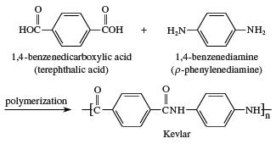

Properties:
When Kevlar is spun, the resulting fiber has a tensile strength of about 3,620 MPa, and a relative density of 1.44. Kevlar maintains its strength and resilience down to cryogenic temperatures (−196 °C); in fact, it is slightly stronger at low temperatures.
Kevlar's structure consists of relatively rigid molecules which makes them exceptional strong
They are high tensile strength-to-weight ratio; by this measure it is 5 times stronger than steel.
USES:
Kevlar has many applications, ranging from bicycle tires and racing sails to bulletproof vests,
It is also used to make modern marching drumheads that withstand high impact.
Kevlar is a well-known component of personal armor such as combat helmets, ballistic face masks, and ballistic vests. It is used for motorcycle safety clothing, especially in the areas featuring padding such as shoulders and elbows.
Poly Lactic Acid:
- Polylactic acid, also known as poly(lactic acid) or polylactide (abbreviation PLA) is a thermoplastic polyester
- The monomer is typically made from fermented plant starch such as from corn, sugarcane or sugar beet pulp.

Synthesis:

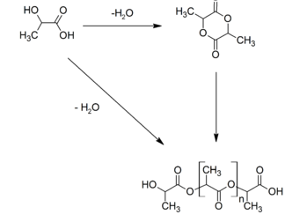

- The most common route to PLA is the ring-opening polymerization of lactide with various metal catalysts (typically tin octoate) in solution or as a suspension.

Properties:

- It is linear thermoplastic polymer
- It is crystalline in nature
- It has glass transition temperature of 50-80 degree celsius
- It can be converted in to fiber
- It is soluble in many organic solvent
- Because of chiral atom it shows stereo isomers
- It is biodegradable

Application:
- PLA is used in a large variety of consumer products such as disposable tableware, cutlery housings for kitchen appliances and electronics such as laptops and handheld devices, and microwavable trays.
- PLA can degrade into innocuous lactic acid, so it is used as medical implants in the form of anchors, screws, plates, pins, rods, and mesh.
- Depending on the exact type used, it breaks down inside the body within 6 months to 2 years. This gradual degradation is desirable for a support structure

Polydimethylsiloxane:

- Polydimethylsiloxane (PDMS), also known as dimethylpolysiloxane or dimethicone, belongs to a group of polymeric organosilicon compounds that are commonly referred to as silicones. PDMS is the most widely used silicon-based organic polymer as its versatility and properties lead to many applications.
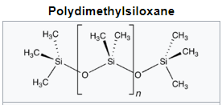

- The chemical formula for PDMS is CH₃[Si(CH₃)₂O]_{n}Si(CH₃)₃, where n is the number of repeating monomer [SiO(CH₃)₂] units. Industrial synthesis can begin from dimethyldichlorosilane and water by the following net reaction:
- For medical and domestic applications, a process was developed in which the chlorine atoms in the silane precursor were replaced with acetate groups. In this case, the polymerization produces acetic acid, which is less chemically aggressive than HCl.
- PDMS is viscoelastic, meaning that at long flow times (or high temperatures), it acts like a viscous liquid, similar to honey.
- The mechanical properties of PDMS enable this polymer to conform to a diverse variety of surfaces. Since these properties are affected by a variety of factors, this unique polymer is relatively easy to tune.
- Depending on the application and field, the user is able to tune the properties based on what is demanded.

Conducting Polymers:
Polymers are known to have insulating materials. The biggest advantage of conductive polymers is their processability, mainly by dispersion. The electrical properties can be fine-tuned using the methods of organic synthesis and by advanced dispersion techniques. These are following conducting polymers
- Intrinsicalliy conducting polymers (ICP)
- Doped Conducting Polymer (DCP)
- Extrinsically conducting polymer (ECP)

Intrinsically conducting polymers (ICP)
These posses conjugated “pi” (π) electron backbone. When such polymer faces electric field, these electron get excited and hence move through polymeric materials. The orbital of conjugated pi electron get overlapped on the backbone and hence valence band and conduction band are developed whiich get distributed over entire surface of polymer. Appropriate proportion of conjugated “pi” (π) electron makes polymer to conduct electricity very efficiently.
Aromatic : Poly aniline, Poly anththrylene
Aromatic heterocyclic: Poly pyrrole, poly thiophene, poly butadiene
Doped Conducting Polymer (DCP)
These are prepared by exposure of the polymer to a charged transfer agent either in gas phase or in liquid phase (solution). As compared to plain ICP, these have low I.P. but high E.A. Hence these can easily oxidized or reduced. ICP can made more conducting by creating positive or negative charge on its backbone by oxidation or reduction.
This technique is called doping . These are two type of doping
- P doping
- N doping

I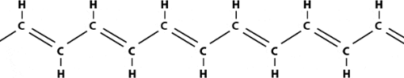
1-oxidation with halogen (or p-doping).
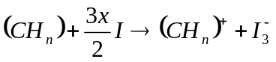

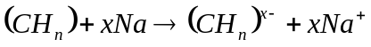2. Reduction with alkali metal (called n-doping)

The halogen doping transforms polyacetylene to a good conductor.
Oxidation with iodine causes the electrons to be jerked out of the polymer, leaving "holes" in the form of positive charges that can move along the chain. The iodine molecule attracts an electron from the polyacetylene chain and becomes I3ֿ. Doped polyacetylene is, e.g., comparable to good conductors such as copper and silver, whereas in its original form it is a semiconductor.

- Extrinsically conducting polymer (ECP)
These are the conducting polymers which posses conductivity due to externally added ingredient in them. There are two types of ECPs
Conducting element filled polymer
In this type resin or polymer is filled up with conducting element e.g. carbon black , metallic fibers , metal oxide etc. The polymer holds the metallic element thus acting as a binder. Their conduting is reasonable high.

Application of conducting Polymer
In rechargeable light battery
Optically display device.
Super capacitor
In wiring in aircraft and aerospace component
In telecommunication system
In electromagnetic screening material
Solar cell, photovoltaic device.

